

**Minor Project**

**On  
Digit & Character Recognition**

Academic Year: 2022-23

|  |  |
| --- | --- |
| Student’s Full Name | Patel Fenil bharatkumar  Patel Krunalkumar Maheshbhai  Vaghani Jeel Kiranbhai |
| Enrollment No | 20SE02ML032  20SE02ML033  20SE02ML050 |
| Branch | CSE(Artificial Intelligence & Machine Learning) |
| Semester | 6 |

Supervised by

**Mr . AAKASH GUPTA**

**Assistant Professor**

P P Savani School of Engineering

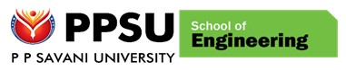

# CERTIFICATE

This is to certify that Mr. PATEL FENIL BHARATKUMAR ,

Enrollment No. 20SE02ML032 from the Department of CSE(Artificial Intelligence & Machine Learning), has successfully completed the Major

Project on the Digit & Character Recognition during Academic Year

2022-23.

Date:

_____________________________ _____________________________

Name and Sign of Supervisor Dean, SOE



# CERTIFICATE

This is to certify that Mr. PATEL KRUNAL MAHESHBHAI ,

Enrollment No. 20SE02ML033 from the Department of CSE(Artificial Intelligence & Machine Learning), has successfully completed the Major

Project on the Digit & Character Recognition during Academic Year

2022-23.

Date:

_____________________________ _____________________________

Name and Sign of Supervisor Dean, SOE



# CERTIFICATE

This is to certify that Mr. VAGHANI JEEL KIRANBHAI ,

Enrollment No. 20SE02ML050 from the Department of CSE(Artificial Intelligence & Machine Learning), has successfully completed the Major

Project on the Digit & Character Recognition during Academic Year

2022-23.

Date:

_____________________________ _____________________________

Name and Sign of Supervisor Dean, SOE

## ACKNOWLEDGEMENT

We feel elated in manifesting our sense of gratitude to our project guide(s) Mr. Aakash Gupta. He has been a constant source of inspiration for us and we are very deeply thankful to him for his support and valuable advice

We are extremely grateful to our Departmental staff members, Lab technicians and Nonteaching staff members for their extreme help throughout our project.

It is indeed with a great pleasure and immense sense of gratitude that we acknowledge the help of these individuals. We are highly indebted to our Dean **Dr. Niraj Shah**, Dean,

School of Engineering, P P Savani University, for the facilities provided to accomplish this MINOR PROJECT.

Finally, we express our thanks to all of our friends who helped us in successful completion of this project.

**Fenil Patel – 20SE02ML032**

**Patel Krunal – 20SE02ML033**

**Vaghani Jeel -20SE02ML050**

## ABSTRACT

This Project is about the tool by which written digit(0-9) and character(A-Z) have been recognized . And I named this tool “**Digit & Character Recognition”**. It includes Drawing , Cropping , and Predicting the digit(0-9) and character(A-Z) . This Idea was coming through a Statement of all Students and Teachers that “what have you written in your Assignment or notes i can't figure out”, for this solution is to create a tool by which the Words, Sentences etc can be recognized. By this i create a tool which will predict what is written in the WhiteBoard. This is only the First level of this idea. In this first level the prediction rate is highly true in the real World.

**TABLE OF CONTENTS**

|  |  |  |
| --- | --- | --- |
| **Sr. No** | **Component** | **Page. No.** |
| 1. | Chapter 1: Introduction to Project | 8 |
| 2. | Chapter 2: Literature Review | 9 |
| 3. | Chapter 3: System Design and Diagrams | 10 |
| 4. | Chapter 4: Implementation Details | 14 |
| 5. | Chapter 5: Conclusion and Future Work | 30 |
| 6. | REFERENCES | 31 |

**TABLE OF CONTENTS**

|  |  |  |
| --- | --- | --- |
| **Sr. No** | **FIGURES** | **Page. No.** |
| 1. | Diagram Steps to Use this Tool | 10 |
| 2. | Diagram Model | 11 |
| 3. | Diagram drawing wok on Model | 12 |
| 4. | Diagram Crop work on Model | 13 |
| 5. | Diagram Accuracy of the Model | 19 |
| 6. | Output of the Model Tool | 29 |

**CHAPTER 1**

**INTRODUCTION TO PROJECT**

**OBJECTIVE OF PROJECT:**

The purpose for making this project was to recognize the handwritten digit(0-9) and character(A-Z) by predicting it.

**BACK END TOOL:**

PYTHON

This Project is about the tool by which written digit(0-9) and character(A-Z) have been recognized . And I named this tool “**Digit & Character Recognition”**. It includes Drawing , Cropping , and Predicting the digit(0-9) and character(A-Z) .For this Project ,I learned about OpenCV(Computer Vision) , CNN(Convolutional Neural Network) , MNIST(Modified National Institute of Standards and Technology ) . I use Python Programming Language, Because all these things are easily available as a library in Python.

**CHAPTER 2**

**LITERATURE REVIEW**

* OpenCV(Computer Vision)
* OpenCV-Python is a library of python bindings designed to solve computer vision problems.
* OpenCV is a huge open-source library for computer vision ,machine learning, and image processing.
* It can process images and videos to identify objects , faces , or even the handwriting of a human.
* CNN(Convolutional Neural Network)
* Convolutional Neural Network is a Deep Learning algorithm specially designed for working with Images and videos. It takes images as inputs, extracts and learns the features of the image, and classifies them based on the learned features.
* MNIST(Modified National Institute of Standards and Technology )
* The MNIST dataset is a large database of handwritten digits. It commonly used for training various image processing systems. MNIST is short for Modified National Institute of Standards and Technology database.

**CHAPTER 3**

**SYSTEM DESIGN AND DIAGRAMS**

* Workflow of project by diagram/algorithms and necessary explanations

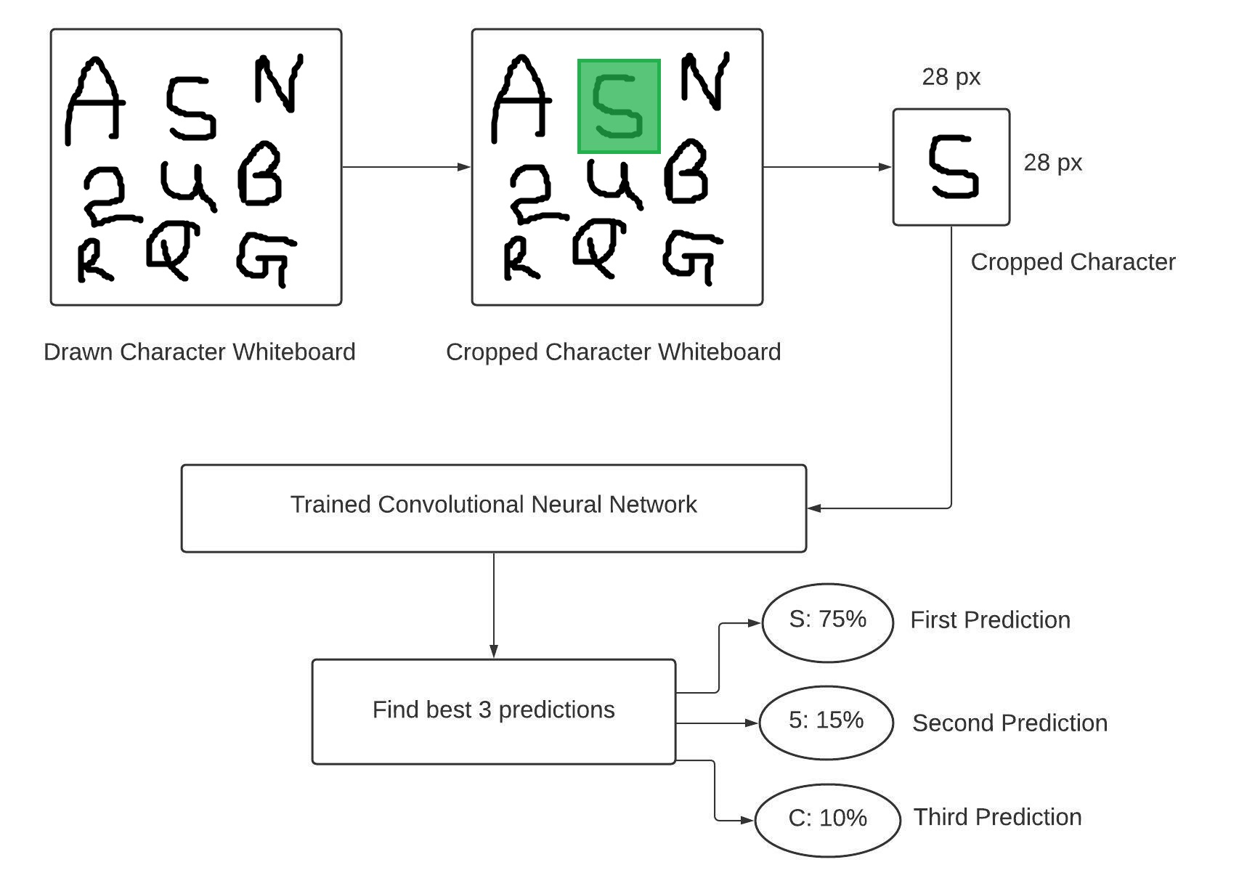

**Figure :- 1→ Diagram Steps to Use this Tool**

* This tool is in the form of a major window with minor windows in it.

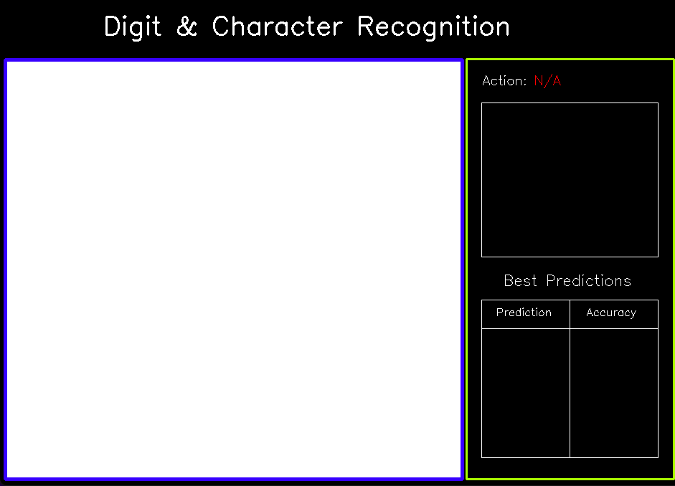

**Figure :- 2→ Diagram Model**

* Firstly you have to draw any random digit(0-9) and character(A-Z) in a window by clicking d on the keyboard which will activate the drawing command.

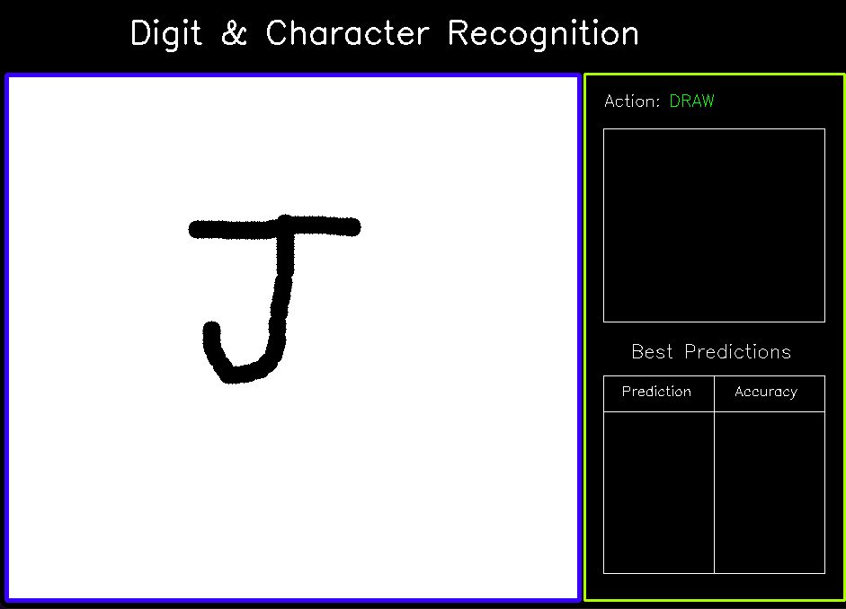

**Figure :- 3→ Diagram drawing work on Model**

* After this , you have to click c on the keyboard to activate the cropping command. You have to crop the digit(0-9) and character(A-Z) you have drawn .
* After cropping it ,the image cropped will appear in another window, and then next window below it will predict what is written.

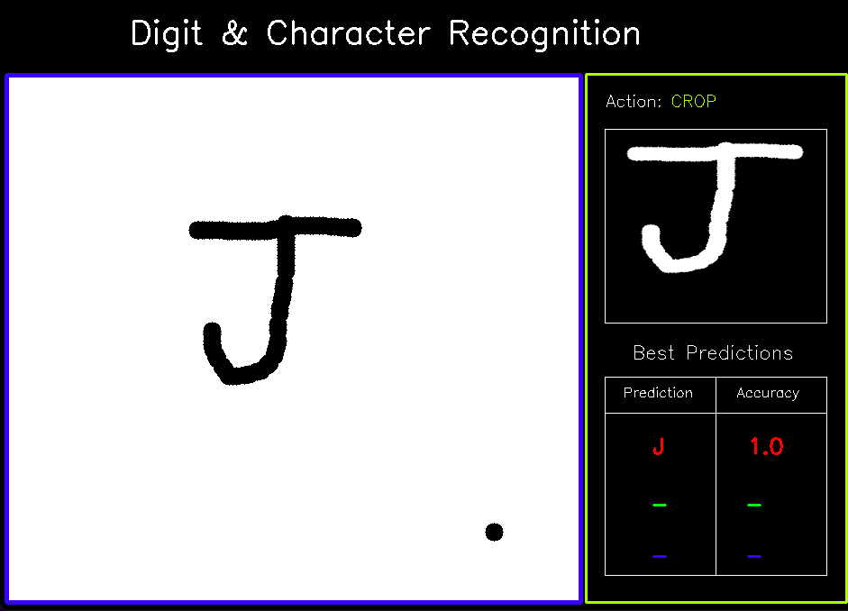

**Figure :- 4→ Diagram Crop work on Model**

**CHAPTER 4**

**IMPLEMENTATION DETAILS**

* This project is done in Three structure:-

1. Data preprocessing
2. CNN Architecture
3. Application

1. **DATA PREPROCESSING**

* In this Structure the libraries import are

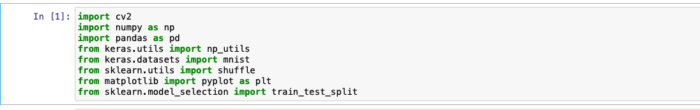

* Then upload the data of A-Z handwritten in csv format and load mnist data.

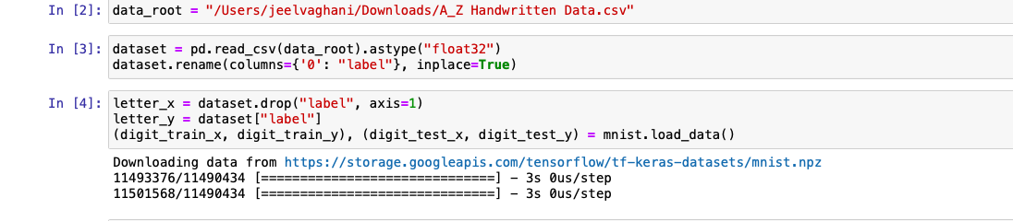

* The size of their train and test data.

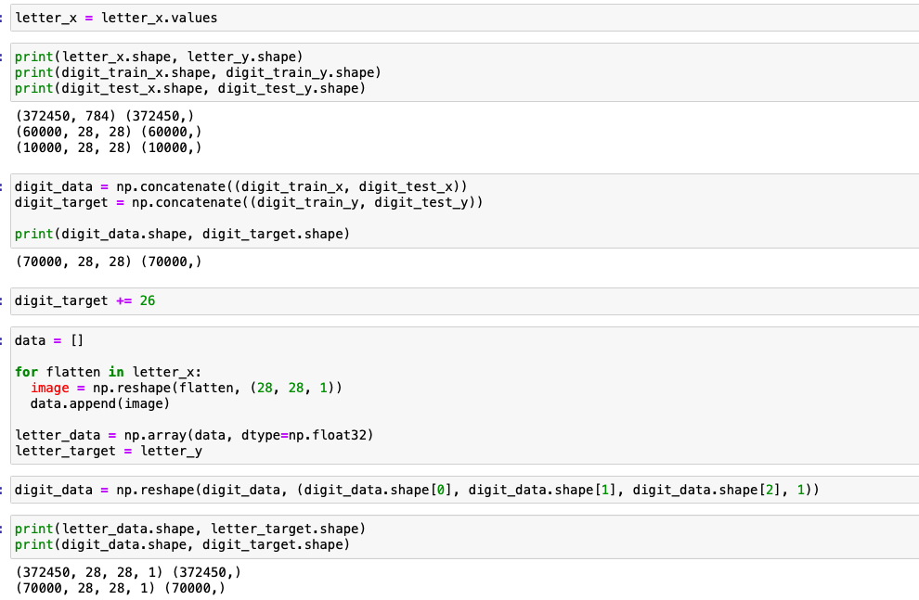

* Transform data in image form and shuffle

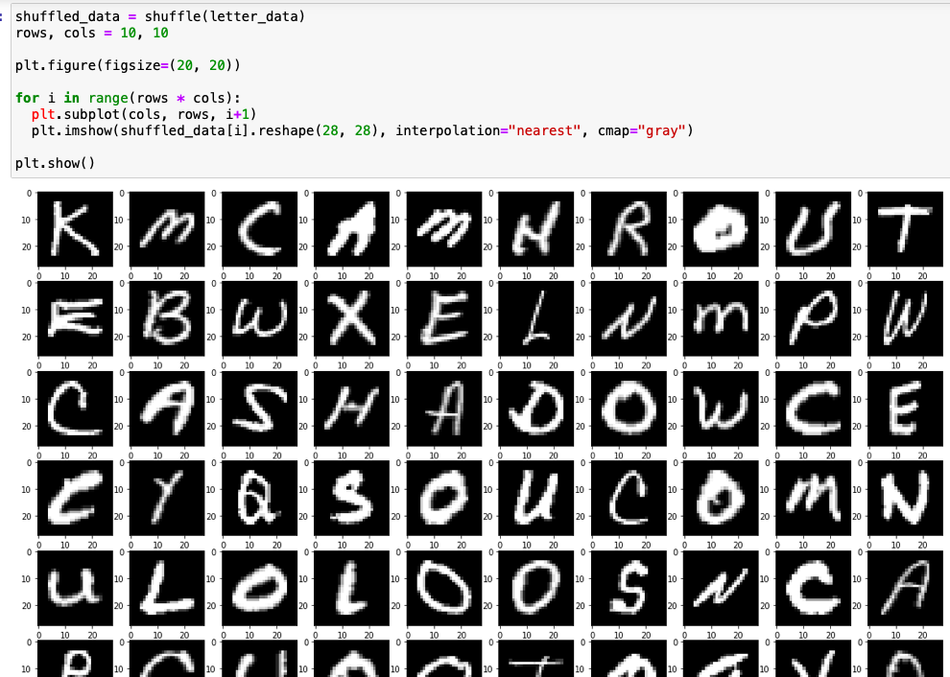

* the size of the new train data and test data of the mixture of A-Z handwritten and mnist data. and save it in a new file.

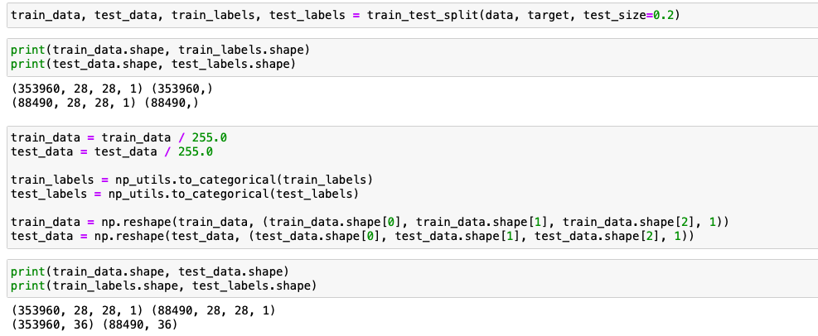

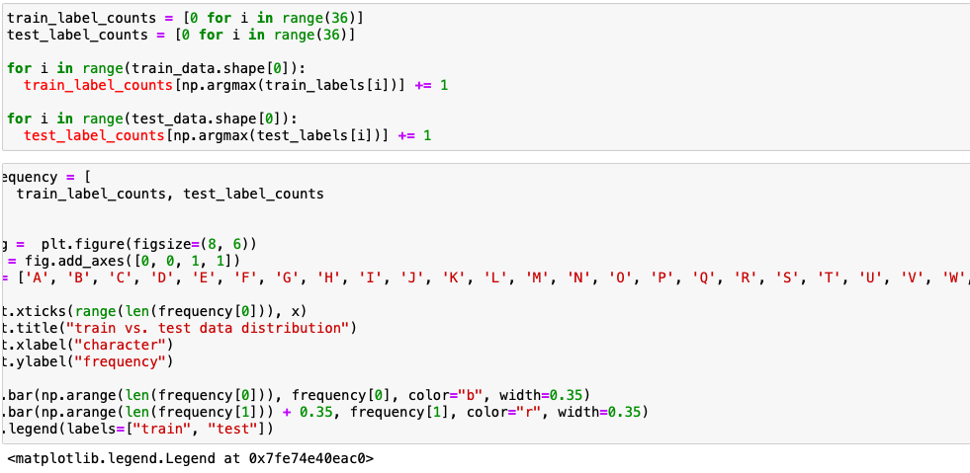

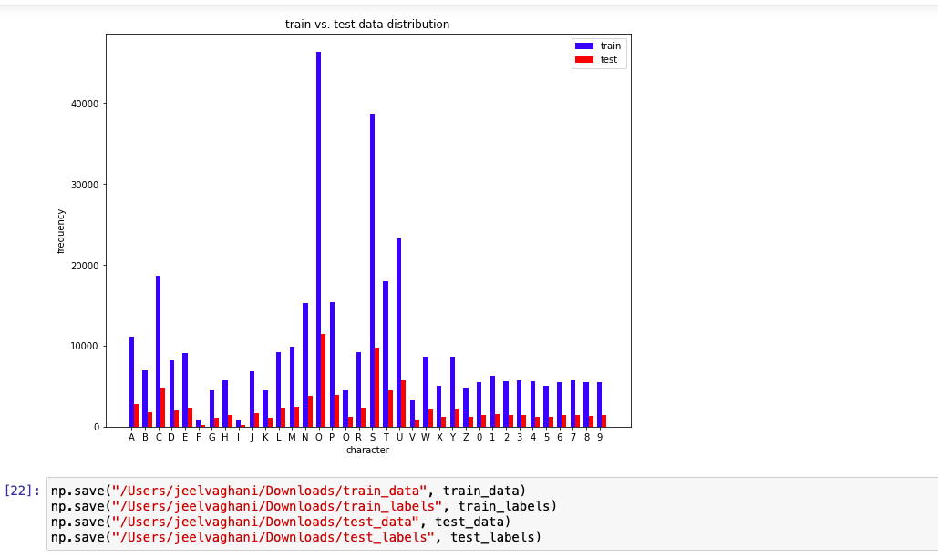

**Figure :- 5→ Diagram Accuracy of the Model**

1. **CNN Architecture**

* In this Structure the libraries import are

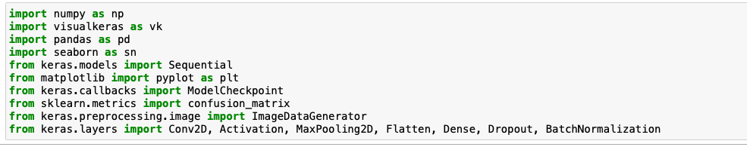

* Load the data and prepare them for process.

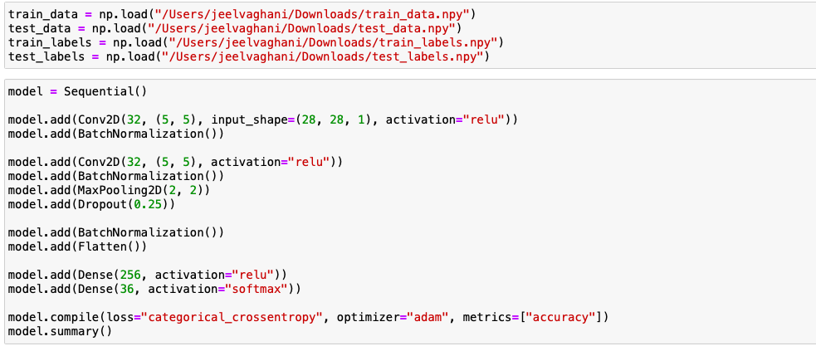

* Upload the best val loss modal and best loss model to train our data.

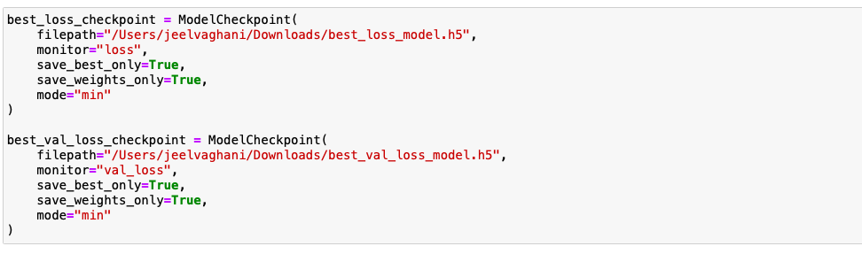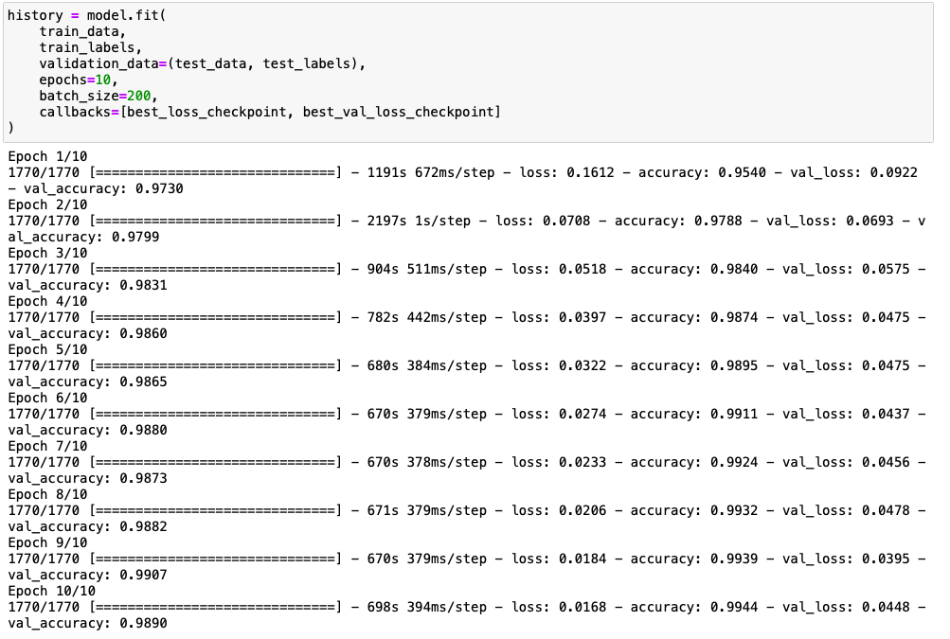

* After Training the new accuracy is

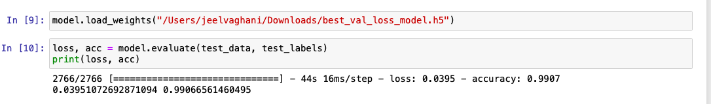

* After this our accuracy rate is 99%.
* The prediction of any handwritten digit and character will match any of the images from the new mix data will predict accurately what has been written.

1. **Application**

* Here is the last part of my Project, where i have built windows by using OpenCV where we will perform our project.



* Making a WhiteBoard and Setup Display for it.

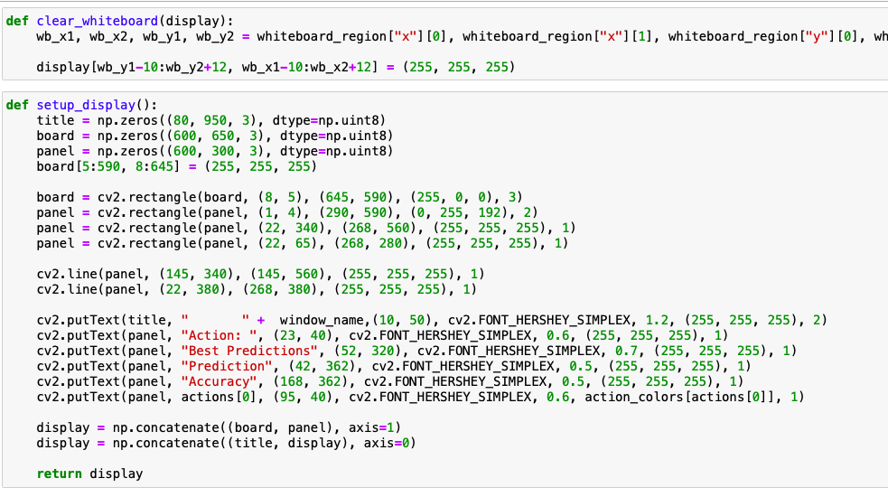

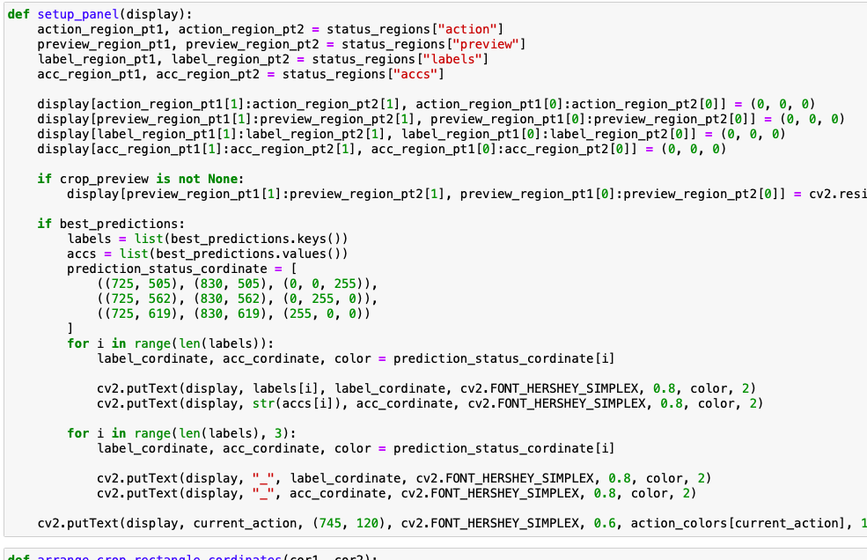

* Creating a Crop tool to crop the drawing by using a mouse click event.

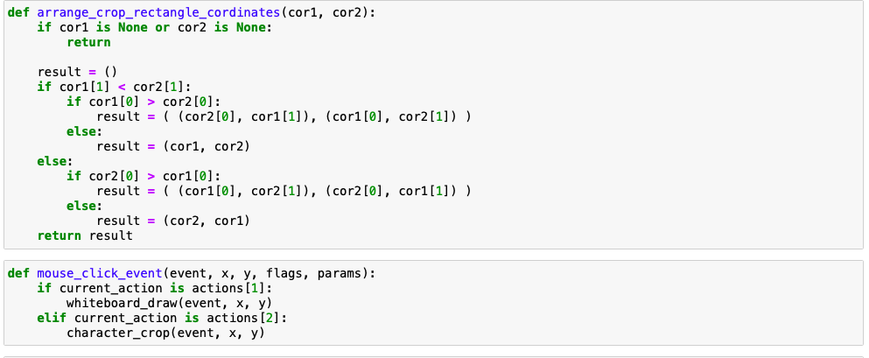

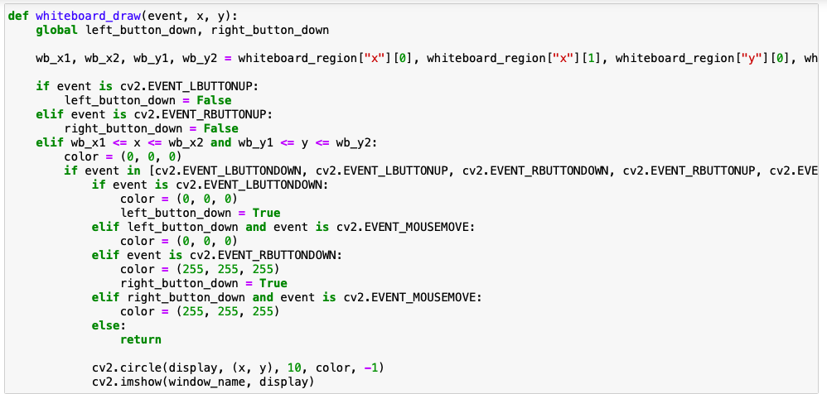

* Load the model to predict the digit and character .

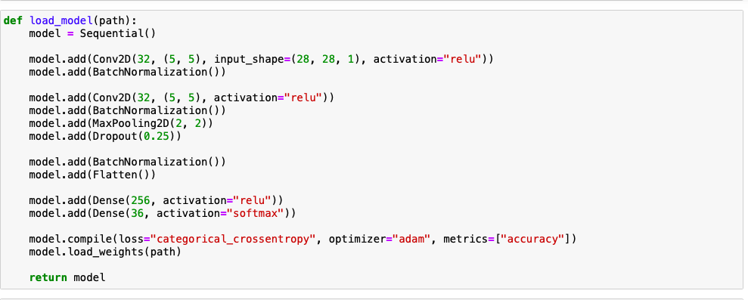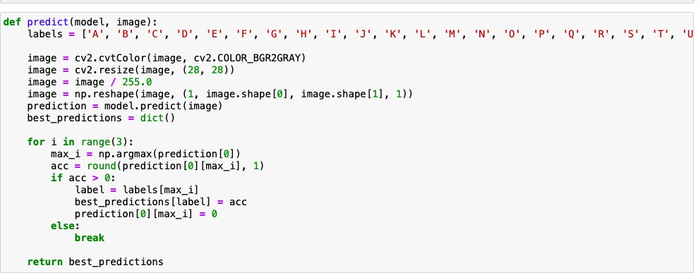

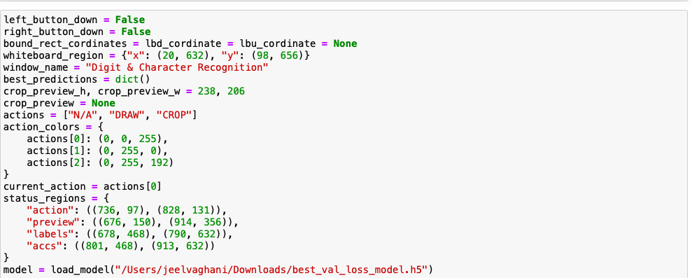

* Assigning the keys for the action like D for Drawing and C for Crop .

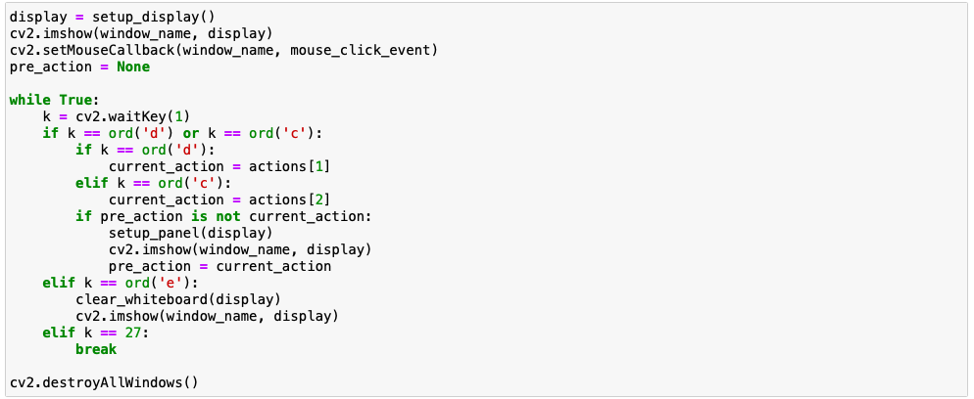

OUTPUT OF THE MODEL TOOL

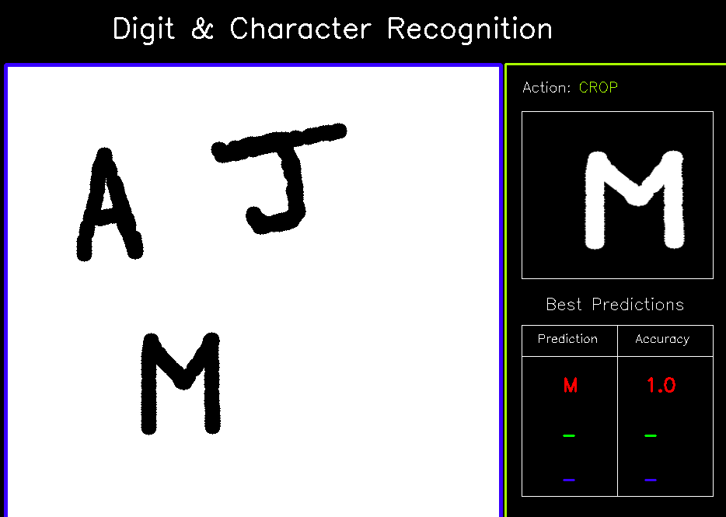

**Figure :- 6→ Output of the Model**

**CHAPTER 5**

**CONCLUSION AND FUTURE WORK**

CONCLUSION:

* This project will work as a tool to predict the handwritten digit and character.

FUTURE SCOPE:

* This tool is just a step for only predicting only one handwritten digit and character , but in the future maybe we can create a scanner which will predict the whole word and lastly predict the whole sentence and print in computer typing format.

**REFERENCES**

* Dataset from 1)<https://www.kaggle.com/datasets/sachinpatel21/az-handwritten-alphabets-in-csv-format> —> for A-Z dataset

2) <http://yann.lecun.com/exdb/mnist/> ----> MNIST

* learn OpenCV

<https://youtube.com/playlist?list=PLS1QulWo1RIa7D1O6skqDQ-JZ1GGHKK-K>

Youtube Channel :- <https://www.youtube.com/c/ProgrammingKnowledge>

* learn CNN

<https://www.geeksforgeeks.org/introduction-convolution-neural-network/>

* learn to create whiteboard

<https://www.twilio.com/blog/collaborative-whiteboard-python-flask-twilio-sync>

<https://www.geeksforgeeks.org/convert-opencv-image-to-pil-image-in-python/>

* crop an image in opencv

<https://stackoverflow.com/questions/15589517/how-to-crop-an-image-in-opencv-using-python>

* Machine Learning

<https://www.geeksforgeeks.org/machine-learning/>

* About Digit & Character Recognition

<https://ejournal.upi.edu/index.php/ijost/article/view/10795>